Name:
Ancient India Review
_____

_____

_____

_____

_____

_____

_____

_____

_____

_____

_____

_____

____

______

A. Reincarnation
B. Karma
C. Dharma
D. Hinduism
E. Buddhism
F. Citadel
G. Granaries
H. Monsoon
J. Vedas
K. Four Noble Truths
M. Subcontinent
N. Middle Way
O. Eightfold Path
P. Migrate
Q. Sanskrit
- The main building in an Indus Valley city that contains the government building.

- A way of life in Buddhism that is neither too easy nor too strict.

- The Hindu cycle of birth, death, and rebirth.

- The ancient book of songs and hymns that tells Hindus how to live and act.

- A large landmass that is separated from the rest of a continent by geographical features.

- To move from one place to another.

- This religion was based on the idea that people have religious duties to fulfill and must treat people with respect and kindness.

- This can be summed up as “what goes around comes around.”

- This religion believed that the most important thing in life is to find peace by ending suffering.

- This makes up the Fourth Noble Truth.

- This was the religious duties of each caste.

- Seasonal wind.

- Building where extra food is stored.
- The Aryan writing system.

- What made it possible for the farmers of the Indus Valley to harvest crops two times a year?
- How does the language of the Harappan culture affect our understanding of their society?
- What is karma? How can it affect a person’s place in the caste system?
- According to Buddhists, what is the only way for people to end suffering in their lives and in the world?
- What two important things did the Aryans bring with them when they migrated to India in 1500 BC?
- What is the name of the prince that founded Buddhism?
- List the Four Noble Truths.

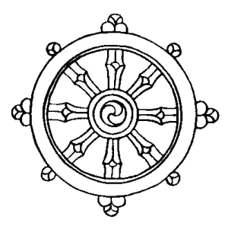
- What does this symbol represent?

Fill in the 5 different castes in Ancient Indian society. Then draw a line to the body part or area where each class began.

1._____________________________
2. _____________________________
3. _____________________________
4. _____________________________
5. _____________________________

