MULTIPLE CHOICE Read each statement or question. On the lines below write the letter of the best answer.

1. What middle colony was originally founded by the Dutch, but later taken over by the English?
a. Pennsylvania
b. New Jersey
c. Delaware
d. New York
2. Why did William Penn create the colony of Pennsylvania?
a. He wanted to provide a home for Quakers.
b. He wanted to practice nonviolence.
c. He wanted to escape Puritan control.
d. He wanted to break away from England.
3. Which Middle Colony was originally part of New Amsterdam?
a. New Hampshire
b. New Jersey
c. Delaware
d. Pennsylvania
4. What is the term for crops that are always needed?
a. staple crops
b. natural crops
c. plantation crops
d. cash crops
5. What helped the Quakers get along with the natives better than other people?
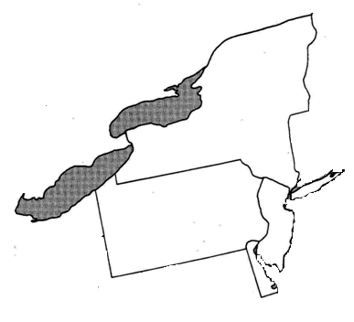
a. Their farming ability
b. Their belief in nonviolence
c. The Quaker’s clothing
d. Their location wasn’t near natives

Label the map at right
6
5
4
3
2
1

